**Documentation**

***module Mux2x1(out,in1,in2,s);***

**Input :**

**in1,in2**

input fed into the component

**s**

signal input

**Output :**

**out**

to store and give out the final output

**Behavior :**

Acts as the output which saves the values of input based on the value of s

***module Or(out,a,b);***

**Input :**

**a,b**

input that needed to be or gated

**Output :**

**out**

to store and give out the final output

**Behavior :**

Represents as the or gate to give out the final or-ed output.

***module PEncoder(out,used,******in1,in2,in3,in4);***

**Input :**

in1,in2,in3,in4

represents the signal position in of the traffic light signal at a particular instant.

**Output :**

**out**

stores the traffic signal position based on the input values

**Behavior :**

Stores the values of state of the traffic signal position that need to executed at the moment. This is used when there is a special occasion where the traffic signals needed to manipulated in favor of a particular;ar vehicle movement e.g: Ambulance, VIP transportation. This is input completely under the sensor control.

***module Decoder(o1,o2,o3,o4,in);***

**Input :**

**[1:0]in**

accepts the signal for the traffic controller that is obtained

**Output :**

**o1,o2,o3,o4**

stores the output for the enabler for the LightBoard

**Behavior :**

acts as a Decoder to assign the value to each of LightBoard

***module TimerIC(clk,reset,mode,BoardSelect) ;***

**Input :**

**clk**

to change to the next value of timer. acts as the clock

**reset**

to change the value to its original value to reset the value. this is used when the priority encoder is used to pull 0the system back to the original condition after the emergency situation is been handled.

**Output :**

**mode**

to select among the 2 modes of the traffic signal.

**BoardSelect**

to enable the traffic signals that needed to put forth across the road

**Behavior :**

to increase the counter to cycle through the modes and LightBoards

***module LightBoard(enable,mode,mode_out,out) ;***

**Input :**

**enable**

to enable the LightBoard

**mode**

to determine the mode of the traffic

**Output :**

**mode_out**

to reconfigure the opposite traffic signal depending on the current light signal

**[4:0]out**

binary digits representing the color that needed to be emitted

5'b (red)(orange)(Green-left)(Green-Front)(Green-Right)

**Behavior :**

Gives the lights that needed to emitted in one traffic signal among four in one junction of among 5 junctions

***module TrafficSignal(clk,imgDataOut,imgData,active,p,e) ;***

**Input :**

**clk**

to change to the next value of timer. acts as the clock

**[1024:0]imgData;**

to store the image matrix data obtained from compared sample

to store the image data

**[3:0]p**

Load priority signal variable. To indicate which road or mode needed to be changed to so as to decrease the traffic load

**[3:0]e**

Emergency signal variable. To indicate which road or mode needed to be changed to, so a to to decrease the movement of vehicles along a particular lane allowing vehicles of high values to pass through

**Output :**

**[1023:0] imdDataOut:**

to pass the image from traffic signal to the other so the image can be verified at the next traffic signal

**active**

to check the flag of the signal from which the imgData is obtained so we could compare the car that passes the both signals

**[4:0]outF**

**[4:0]outL**

**[4:0]outR**

**[4:0]outB**

outputs the lights that are activated in light boards in one traffic signal in a junction

F, L, R , B represents Front, Left, Right, Back

**Behavior :**

This module contains one junction of the system. It has four TrafficSignals of one junction

The TrafficSignal

***module TrafficSystem(clk,imgDataIn1 ,imgDataIn2 ,imgDataIn3 ,imgDataIn4 ,imgDataIn5,signal,ans);***

**Input :**

**clk**

to change to the next value of timer. acts as the clock

**[1023:0] imgDataIn1 ,imgDataIn2 ,imgDataIn3 ,imgDataIn4 ,imgDataIn5**

to accept the image data obtained from each of the traffic signal from each junction so they can be compared with each other TrafficSignal

**[4:0]signal**

to accept which traffic signal is giving out the image data to be compared.

**Output :**

**[4:0]ans**

to store the values characters in terms of numbers i.e. [ a=1, b=2, ... z=26 ]

**Behavior :**

This is final module which determines the working of the entire TrafficSystem

TrafficSystem coordinates the working of the five TrafficSignals in a harmonic manner

It also contains processing of the image data and redirects the processed image to the other TrafficSignals for checking.

***module Segment&7(Out,In)***

**Input :**

[3:0] In

4 bit number running from 0-16

**Output :**

[13:0]Out

Each bit represents each segment in the 7 segment display.

**Behavior :**

Displays the Timer of the current state as 7 segment display

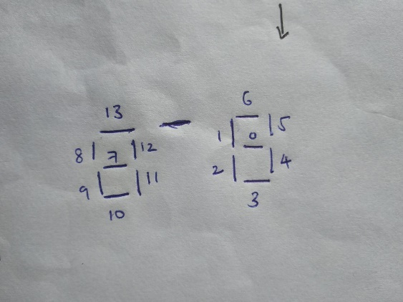

***Requirements***

-Python version 3.60 or greater

-Pillow package